CENG402 Midterm Interim Progress Report

Project Information
Project Title | Artificial Intelligence And Image Processing-Based For Food Intake Measurement And Consumption Pattern Analysis in University Dining Halls
Student Names & Numbers | Cemil Alp (21050111005) Ali Batuhan Zeytün (21050111020) Muhammet Talha Satir (22050111058)
Supervisor Name | Muhammed Abdullah Bülbül
Submission Date | 17/04/2026

Project Overview and Summary (Project Scope & Progress)
This report presents the interim progress of our graduation project, which aims to develop an AI-powered smart cafeteria management system for university dining halls. The system targets food waste reduction, menu optimization, and student satisfaction improvement through data-driven decision making and multiple AI/ML models.
The project has undergone a deliberate and well-justified scope of change since the original Research Proposal and the CENG401 Final Report. The original plan involved installing fixed cameras at tray-return stations to automatically measure food consumption via YOLO-based before/after image comparison. Due to practical constraints including denied permission for physical camera installation, unresolved privacy and ethics board approval timelines, and cafeteria management's refusal to allow infrastructure modifications the camera-based automatic measurement approach was replaced with a comprehensive AI-driven software platform. The core research objective of reducing food waste through intelligent data analysis has been fully preserved and, in fact, significantly expanded in scope. The data collection mechanism shifted from automated camera capture to a combination of manual production-data entry by cafeteria staff and student photo uploads for food recognition.
As of the submission date, the system includes five AI/ML modules, over 70 registered FastAPI routes, 14 HTML templates, 51 automated tests, a CI/CD pipeline, and advanced capabilities including A/B testing, automatic model retraining, and real-time WebSocket updates.

Problem Definition and Specific Objectives
University dining halls serve large numbers of meals daily and operate under strict time and cost constraints. Despite this scale, most cafeterias lack objective, dish-level data that describe how much of each served meal is actually consumed. Meal production decisions are therefore based largely on intuition or historical habits rather than measurable consumption patterns. As a result, unpopular dishes may continue to be overproduced, leading to excessive food waste, unnecessary operational costs, and negative environmental impact. Food waste in institutional dining environments primarily occurs at the post-consumption stage, where significant portions of meals remain uneaten on returned trays. Existing waste measurement approaches, such as manual observation, weighing leftovers, or periodic surveys, are labor-intensive, subjective, and impractical for continuous daily use. Moreover, these methods fail to provide fine-grained, dish-specific insights that could support targeted menu optimization. While recent advances in computer vision and artificial intelligence have enabled food recognition and nutritional analysis, most existing systems focus on personal dietary tracking rather than large-scale institutional monitoring. There is currently no widely adopted automated solution capable of continuously measuring dish-level consumption in real cafeteria environments without disrupting operations. This gap prevents dining hall administrators from making data-driven decisions aimed at reducing waste and improving resource efficiency.

Specific Objectives

- Develop an AI-Based Waste Prediction System: Implement an ensemble machine learning model (RandomForest + GradientBoosting + XGBoost with Optuna hyperparameter tuning) that predicts waste ratios for each dish based on temporal, rating, production, and seasonal features.
- Implement ML-Driven Menu Optimization: Engineer a multi-objective optimization algorithm that generates weekly menu suggestions maximizing popularity and nutritional balance while minimizing predicted waste and cost, subject to diversity and dietary constraints.
- Deploy a Deep Learning Food Recognition Module: Utilize YOLOv8s Classification with an ensemble of Turkish Food (102 classes) and Food-101 (101 classes) models, enabling students to upload meal photos for automatic identification and nutritional analysis.
- Create an AI Chatbot Assistant: Integrate Google Gemini 2.0 Flash with 11 function-calling tools to provide a natural-language cafeteria assistant capable of querying menus, ratings, waste data, and nutritional information.
- Build a Turkish Sentiment Analysis Engine: Develop an NLP pipeline with n-gram matching, negation handling, emoji support, and aspect-based analysis (taste, portion, temperature, freshness, hygiene) to evaluate student feedback in Turkish.
- Establish a Comprehensive Web Platform: Deliver a full-stack application with student-facing and admin-facing interfaces, automated PDF/Excel reporting, real-time WebSocket updates, and a CI/CD pipeline with 51 automated tests.

Scope Change: From Camera-Based to Software-Based Approach

Original Approach (Research Proposal & CENG401 Final Report)
The original project proposed a four-layer architecture centered on physical camera installation:
    - Data Collection: Fixed cameras at tray-return stations capturing plate images before and after meals.
    - Preprocessing: Image segmentation and food region extraction from camera feeds.
    - AI/Deep Learning: YOLO/ResNet-based food recognition and leftover volume estimation; depth sensing for remaining food volume.
    - Application: Dashboard displaying automated consumption patterns and waste analytics.

Reasons for Scope Change
Constraint | Detail
Permission Denial | University administration did not grant approval for installing fixed cameras in the dining hall.
Privacy & Ethics | Continuous student image capture requires KVKK compliance and ethics board approval, which could not be completed within the project timeline.
Physical Infrastructure | Cafeteria management refused any physical modifications to the tray-return area and equipments are very expensive for the students.
Timeline Feasibility | Even if permissions were eventually granted, the hardware procurement, installation, calibration, and data collection cycle would exceed the remaining project schedule.

How the Core Objective Was Preserved
The fundamental research goal of reducing food waste in university dining halls through AI-driven data analysis was not compromised. The data acquisition method was adapted as follows:
Original Component | Replacement in Current System
Fixed camera at tray-return station | Manual production/leftover data entry by cafeteria staff via admin panel.
Before/after image comparison | ML-based waste prediction using 20+ engineered features from production logs, ratings, temporal/seasonal signals.
Depth sensing for volume estimation | Statistical consumption tracking with ensemble ML models.

Original Component | Replacement in Current System
Single-purpose waste measurement tool | Comprehensive multi-module platform (waste prediction + menu optimization + chatbot + sentiment analysis + reporting).
Automated image capture | Student photo upload for food recognition (YOLO module retained as an independent component).

What Was Retained
The YOLO-based food recognition component was fully retained and functions independently. Students can upload food photos via the /recognize page, and the system identifies dishes using YOLOv8s Classification ensemble models. A tray recognition endpoint identifies multiple dishes in a single photograph. This module fulfills the 'image processing' aspect of the project title.

Detailed Methodology, Tools, and Techniques
The system employs a modular, multi-layer architecture where each AI feature operates as a distinct module with its own trained model, connected through a unified FastAPI backend.

Technology Stack

Layer | Technology
Backend | FastAPI (Python 3.10+), 15 active APIRouter route files
Database | SQLite + SQLAlchemy ORM + Alembic migrations (8 tables)
ML/AI | scikit-learn, XGBoost, Optuna, YOLOv8 (Ultralytics), Gemini 2.0 Flash
Frontend | Jinja2 Templates, HTML/CSS/JavaScript (14 HTML templates)
Reporting | ReportLab (PDF) + openpyxl (Excel) + Matplotlib (charts)
Testing | pytest (51 tests), GitHub Actions CI/CD, ruff linter

- Module 1: Waste Prediction (waste_analyzer.py )
- Models: Ensemble of RandomForest + GradientBoosting + XGBoost, tuned via Optuna Bayesian optimization.
- Feature Engineering (20+ features): Day of week, month, season, academic calendar flags (exam week, holidays), estimated student attendance, historical average rating per dish, vote count, previous-day waste autocorrelation, production history signals, ML-predicted popularity score.
- Outputs: Daily/weekly waste reports, per-dish waste scores (0–100), feature importance analysis, predictive alerts for high-risk dishes.
- Training Pipeline: Automated from database records; time-series cross-validation instead of random split; champion-challenger model comparison during retraining.

- Module 2: Menu Optimization (menu_optimizer.py)
- Model: GradientBoosting Regressor for popularity prediction.
- Optimization: Multi-objective with constraint satisfaction maximize popularity and nutritional balance; minimize waste and cost.
- Constraints: Maximum 2 same meat types per week, minimum 1 vegetable day, allergen diversity control.
- Real-World Signal Blending: Synthetic training scores are reinforced with actual student ratings and production consumption data from the database.
- Module 3: Food Recognition (food_recognizer.py )
- Model: YOLOv8s Classification with ensemble architecture.
- Datasets: Turkish Food dataset (102 classes) + Food-101 (101 global classes).
- Endpoints: Single food recognition (/api/recognize-food), multi-dish tray recognition (/api/recognize-tray).
- Post-processing: Menu-aware filtering (reduces confidence for items not on today's menu), confidence-weighted ensemble voting.

Module 4: AI Chatbot (chatbot.py)
- Model: Google Gemini 2.0 Flash with Function Calling.
- Tools: 11 registered functions such as menu query, nutritional lookup, waste report, rating summary, food recognition trigger, production data query, trend analysis, feedback summary, alert check, menu suggestion, general Q&A.
- Fallback: Rule-based keyword matching when API key is unavailable.

- Module 5: Turkish Sentiment Analysis (sentiment_analyzer.py)
- Methods: Rule-based n-gram matching + negation handling + emoji mapping; optional TF-IDF + Logistic Regression model trained on student comments.
- Aspect-Based Analysis: Extracts sentiment for seven dimensions such as taste, portion, temperature, freshness, hygiene, cooking quality, variety.
- Language: Fully Turkish optimized with ASCII folding for informal student text.

Preliminary Results and Current Validation
Representative experimental results already indicate that the implemented modules are functional and measurable at the midterm stage. The following metrics summarize the current validation status of the most mature system components.
Waste Prediction: The latest ensemble waste model was trained on 707 samples. Using 5-fold TimeSeriesSplit cross-validation, it achieved preliminary MAE = 4.597, RMSE = 5.755, and R^2 = 0.213.
Food Recognition - Baseline Experiments: The Food-101 model achieved a top-1 accuracy of 84.79% and a top-5 accuracy of 95.95%, while the Turkish Food model achieved a top-1 accuracy of 86.82% and a top-5 accuracy of 97.25% in classification experiments.
Combined Model Fine-Tuning: The fine-tuned combined-food classification model achieved a top-1 accuracy of 83.21% and a top-5 accuracy of 95.68%, indicating that the recognition pipeline is already usable for web/mobile-assisted cafeteria interaction.
Software Validation: The current system includes 51 automated tests, all passing locally, and a CI/CD workflow that runs linting and automated testing across multiple Python versions.
These results should be interpreted as interim rather than final, especially for the waste-prediction module, because extended real-world cafeteria deployment and large-scale user validation are still pending.
Visual Demonstration of the Current System
Representative visual artifacts from the implemented system are provided below. They document the operational status of the food-recognition subsystem and serve as visual evidence of progress at the midterm stage.
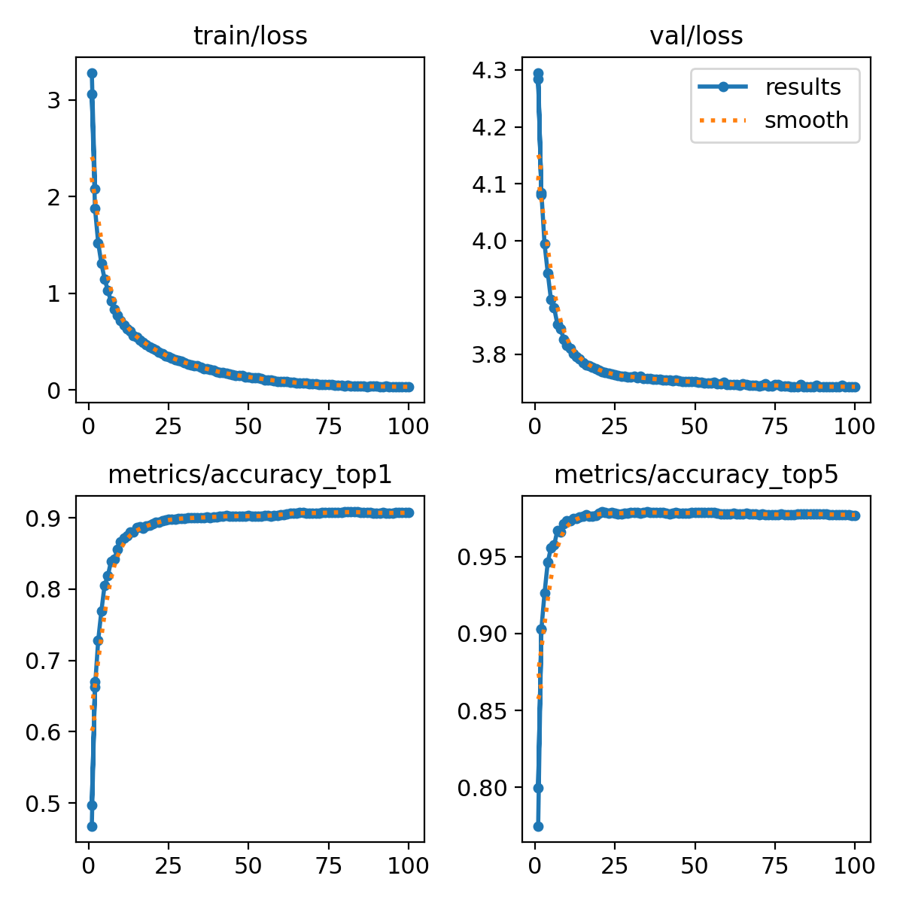
Figure. Training and validation curves for the YOLOv8 Turkish Food classification model.

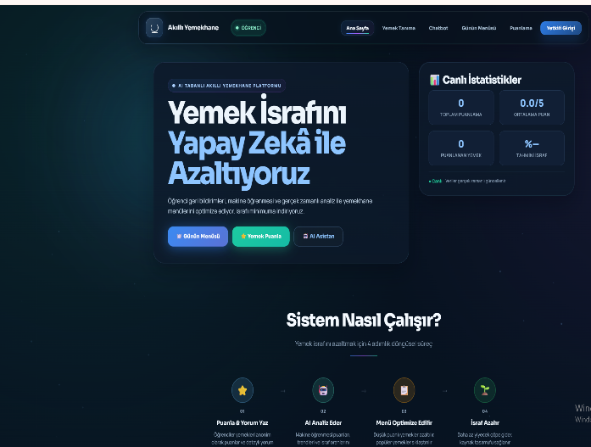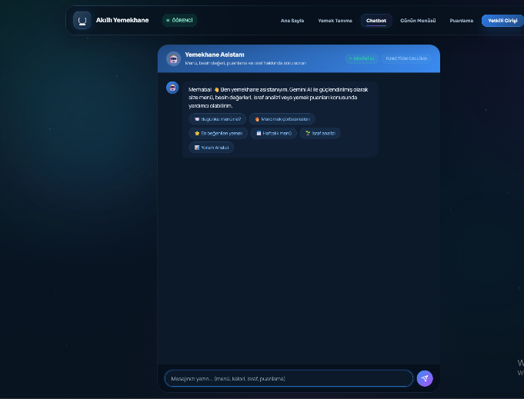
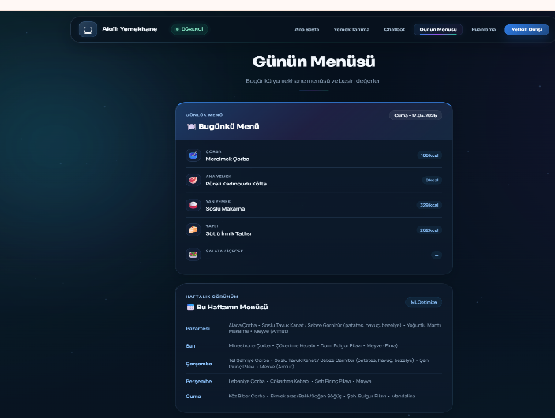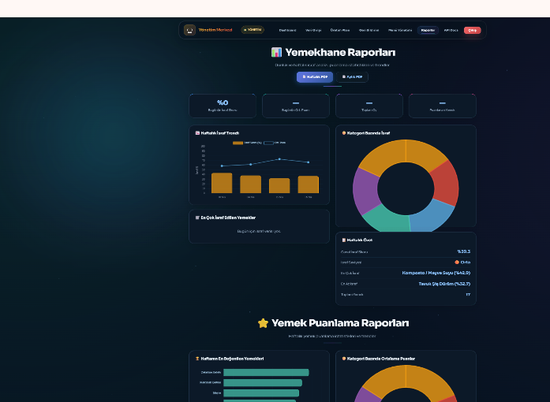
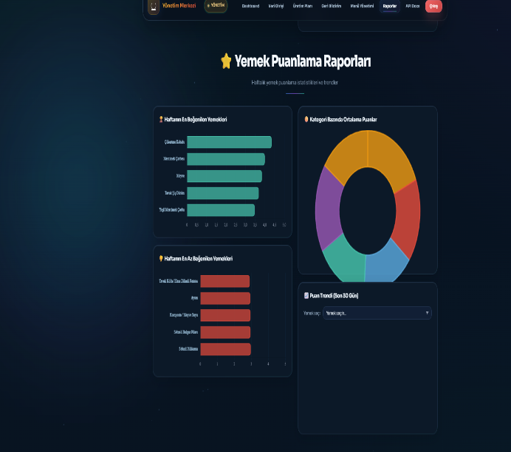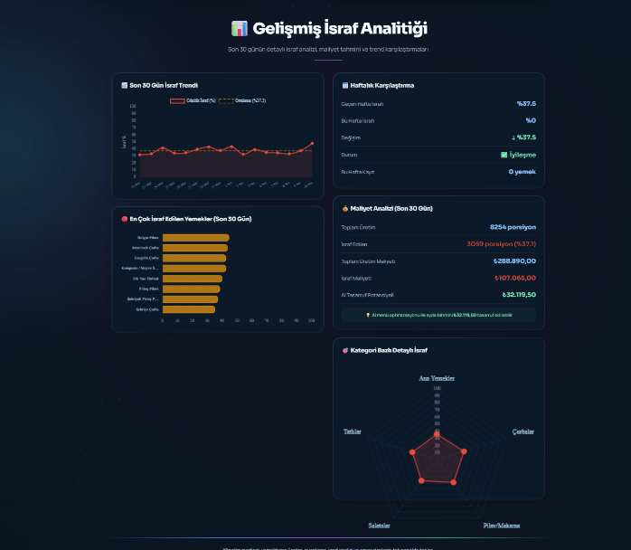
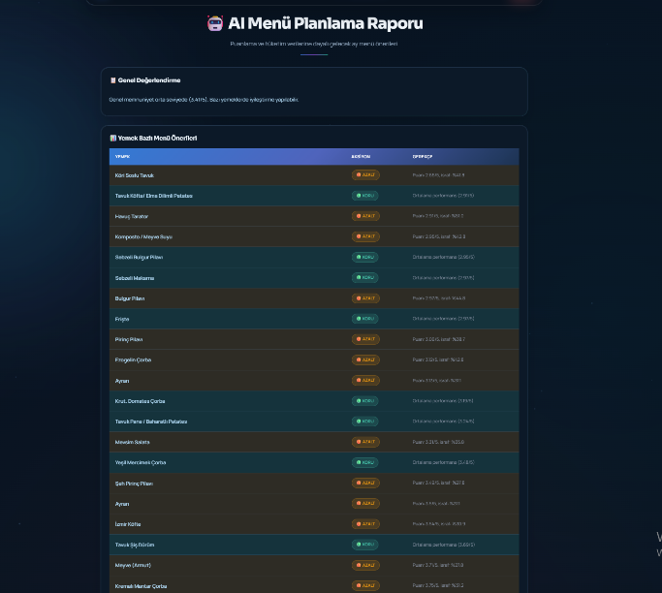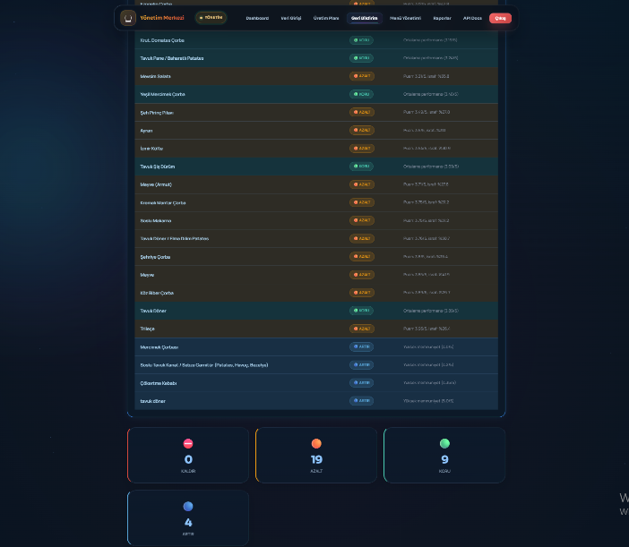

Literature Review

The domain of AI-driven food waste management and smart cafeteria systems has been the subject of growing academic interest. This section surveys the most relevant prior work across the key technical areas of the project.
Food Waste in Institutional Cafeterias. The FAO estimates that roughly one-third of all food produced globally is lost or wasted [1]. Institutional food services, including university cafeterias, are identified as significant contributors. Painter et al. [11] demonstrated that plate waste in university dining halls can reach 15–25% of served food by weight, and that data-driven interventions can reduce this figure substantially. Jochen et al. [2] provided a comprehensive overview of food waste sources in the food service sector and concluded that production planning guided by consumption data is the most effective mitigation strategy —a principle that directly motivates our system’s waste prediction and menu optimization modules.
Machine Learning for Waste Prediction. Several studies have applied ML techniques to predict food waste. Malefors et al. [12] used regression models on cafeteria production logs to forecast daily waste volumes with promising accuracy. Eriksson et al. [13] showed that ensemble methods (Random Forest, Gradient Boosting) outperform single models for waste prediction when temporal and contextual features are included. Our system builds on these findings by combining three ensemble algorithms (RF + GBR + XGBoost) with Optuna-based Bayesian hyperparameter tuning and 20+ engineered features covering temporal, rating, and production signals.
Deep Learning for Food Recognition. The application of convolutional neural networks to food image recognition has advanced rapidly. Bossard et al. [5] introduced the Food-101 dataset, enabling benchmark comparisons across architectures. More recently, the YOLO family of models has been applied to real-time food detection; Jocher et al. [4] demonstrated that YOLOv8 achieves strong accuracy with low latency, making it suitable for mobile and web-based deployment. Our system employs an ensemble of YOLOv8s models trained on both Food-101 and a Turkish Food dataset (102 classes) to handle the specific cuisine of Turkish university dining halls.
Menu Optimization. Computational approaches to menu planning have been explored in the operations research literature. Seljak [14] proposed a multi-objective optimization framework for school menus balancing nutritional adequacy, cost, and preference. Our menu optimizer extends this concept by incorporating ML-predicted popularity scores, historical waste data, and constraint satisfaction (meat variety limits, vegetable day requirements).
LLM-Based Conversational Assistants. The emergence of large language models with function-calling capabilities has enabled a new class of domain-specific chatbots. Schick et al. [15] showed that tool-augmented LLMs can interact with external APIs to retrieve structured data. Our chatbot leverages Gemini 2.0 Flash with 11 registered tool functions, allowing natural-language access to the system’s menu, rating, waste, and nutritional data.
Sentiment Analysis in Turkish. Turkish sentiment analysis presents unique challenges due to agglutinative morphology and informal writing patterns. Demirtas and Pechenizkiy [16] proposed cross-lingual approaches, while Turkmen et al. [17] demonstrated that rule-based methods augmented with n-gram patterns perform competitively for domain-specific Turkish text. Our sentiment analyzer combines n-gram matching, Turkish negation handling, emoji mapping, and aspect-based extraction across seven quality dimensions.
Gap Addressed. While prior work has addressed individual aspects food recognition, waste prediction, or menu optimization in isolation, no existing system integrates all five AI modules (recognition, waste prediction, menu optimization, chatbot, sentiment analysis) into a unified platform specifically designed for Turkish university cafeterias. This project fills that gap by providing a comprehensive, data-driven management tool.

Documentation of Tasks Accomplished
Phase 1: Foundation (CENG401 — First Semester)
- Completed Research Proposal and Literature Review.
- Established project architecture and technology stack.
- Implemented initial database schema (SQLAlchemy ORM, 8 tables).
- Developed YOLO-based food recognition module with Food-101 dataset training.
- Created initial web interface prototypes.
- Delivered CENG401 Final Report.

Phase 2: Core AI Modules (Weeks 1–6, CENG402)
- Waste Prediction Model: Engineered 20+ features; trained RF + GBR + XGBoost ensemble with Optuna tuning; implemented daily/weekly waste reporting; added feature importance analysis.
- Menu Optimization: Implemented multi-objective GradientBoosting model; added constraint satisfaction (meat variety, vegetable day, allergen diversity); integrated real-world rating and production signals.
- Sentiment Analysis: Built Turkish NLP pipeline with n-gram patterns, negation handling, emoji support, and aspect-based analysis across 7 dimensions.
- Chatbot: Integrated Gemini 2.0 Flash with 11 function calling tools; implemented context-aware conversation with database query capabilities.

Phase 3: Software Architecture & Advanced Features (Weeks 7–12)
- Modular Refactoring: Decomposed the backend into 15 active APIRouter route files; centralized shared dependencies.
- Database Migrations: Integrated Alembic with batch-mode SQLite support.
- Asynchronous Pipeline: Implemented FastAPI BackgroundTasks for model training and PDF generation; added task status tracking API.
WebSocket Dashboard: Created real-time update system; integrated broadcast on new ratings
- A/B Testing Engine: Implemented AI menu suggestion vs actual menu comparison with statistical significance testing (Welch's t-test).
- Auto Model Retraining: Built champion-challenger pipeline with state management, data change detection, and backup/rollback mechanisms.
- Advanced Reporting: Added comparative period analysis to PDF reports; implemented Excel export with 4 styled sheets.
- Testing: Created 7 test files with 51 unit/integration tests using pytest; all tests passing.
- CI/CD: Configured GitHub Actions workflow with multi-version Python matrix, automated testing, and ruff linting.

Phase 4: Web Interface (Continuous)
- Developed 14 Jinja2 HTML templates with responsive design.
- Built admin dashboard with comprehensive analytics, charts, and management tools.
- Created student-facing pages: daily menu, rating system, food recognition upload, chatbot interface.
- Implemented production data entry and production planning pages.
Updated Project Schedule
Phase | Task Description | Status
Phase 1 | Research Proposal, Literature Review, Project Planning | Completed
Phase 1 | Database Schema Design, Initial Web Prototypes | Completed
Phase 1 | YOLO Food Recognition Model Training (Food-101 + Turkish Food) | Completed
Phase 1 | CENG401 Final Report Submission | Completed
Phase 2 | Waste Prediction Ensemble Model (RF + GBR + XGBoost + Optuna) | Completed
Phase 2 | Menu Optimization Algorithm (Multi-Objective + Constraints) | Completed
Phase 2 | Turkish Sentiment Analysis (N-gram + Negation + Aspect-Based) | Completed
Phase 2 | Gemini 2.0 Flash Chatbot Integration (11 Function Tools) | Completed
Phase 3 | Modular Architecture Refactoring (15 Active Router Modules) | Completed
Phase 3 | Alembic Database Migrations | Completed
Phase 3 | Background Task Pipeline & WebSocket Real-Time Updates | Completed
Phase 3 | A/B Testing Engine & Auto Model Retraining Pipeline | Completed
Phase 3 | Advanced Reporting (Comparative PDF + Excel Export) | Completed
Phase 3 | Unit & Integration Tests (51 Tests) + CI/CD Pipeline | Completed
Phase 4 | Mobile App Testing, Refinement, and Validation (React Native) | In Progress
Phase 4 | Real Cafeteria Data Collection & Model Validation | In Progress
Phase 5 | User Acceptance Testing with Cafeteria Staff | Pending
Phase 5 | Final Report, Documentation & Presentation | Pending

Discussion of Obstacles and Solutions

Obstacle 1: Camera Installation Denied
Issue: The cornerstone of the original proposal a fixed camera at the tray-return station for automated food intake measurement could not be implemented. University administration denied the camera installation request citing privacy concerns, and the ethics board approval process could not be completed within the project timeline.
Solution: Rather than abandoning the project's core objective, the team made a strategic pivot. The automated camera-based data collection was replaced with a dual approach: (1) manual production and leftover data entry by cafeteria staff through a dedicated admin panel, and (2) student-initiated photo uploads for food recognition. The YOLO food recognition module was retained and continues to function independently via photo upload, preserving the 'image processing' component of the project.

Obstacle 2: Insufficient Real-World Training Data
Issue: ML models for waste prediction and menu optimization require substantial historical data, but the system had no existing data pool at launch.
Solution: A synthetic data generation approach was used for initial model training, combining rule-based popularity scoring with limited real data. As the system collects actual student ratings and production logs, real-world signals are blended with synthetic scores using a weighted formula. An automatic retraining pipeline (champion-challenger architecture) was implemented to continuously improve models as more real data becomes available.

Obstacle 3: Turkish NLP Complexity
Issue: The sentiment analysis module needed to handle informal Turkish student text, including ASCII-only typing, negation patterns unique to Turkish, and emoji-heavy comments.
Solution: A multi-layered NLP pipeline was developed: ASCII folding for character normalization, bi-gram and tri-gram pattern matching, explicit negation handling for Turkish negation words, emoji-to-sentiment mapping, and aspect-based extraction across seven quality dimensions.

Obstacle 4: Monolithic Architecture Scalability
Issue: During CENG401, most API endpoints were implemented in a single, nearly 2,000-line main.py file, making the codebase difficult to maintain, test, and extend.
Solution: The backend was refactored into a modular APIRouter architecture with 15 active route files under api/routes/, a shared dependencies module, and a lean main.py responsible primarily for application startup and router registration.

Limitations, Risks, and Ethical Considerations

Although the current results are promising, the project still has several limitations and deployment risks that must be acknowledged explicitly at the midterm stage.
Limited real-world data: the initial waste-prediction and optimization models still rely partly on synthetic or bootstrapped data because long-term cafeteria deployment data are not yet available.
Generalization risk: food-recognition accuracy may decrease under different lighting conditions, tray layouts, camera quality, and occlusion patterns in real cafeteria use.
Privacy and ethics: any future large-scale image collection must comply with KVKK, institutional privacy requirements, and any ethics-board conditions.
Operational dependency: full end-to-end validation still depends on real cafeteria deployment and staff participation in regular production / leftover data entry.
Language variability: informal Turkish, ASCII-only typing, slang, and emoji-heavy feedback can reduce sentiment-analysis robustness in edge cases.
For these reasons, human oversight remains necessary during deployment, and the final report will include expanded real-world evaluation.
Pending Tasks and Next Steps
- Mobile Application Testing, Refinement, and Validation: The React Native mobile app is already connected to the backend API for menu viewing, food photo recognition, rating submission, and chatbot access; the remaining work focuses on interface refinement, broader device testing, deployment preparation, and full feature validation.
- Real Cafeteria Data Collection: Deploy the admin data entry interface in an actual university cafeteria to collect production/leftover data over a minimum 4 week period for model validation.
- Model Validation with Real Data: Retrain waste prediction and menu optimization models using collected real-world data; measure actual MAE, RMSE, and R² improvements compared to synthetic training.
- User Acceptance Testing: Conduct structured testing sessions with cafeteria staff (for admin panel usability) and students (for rating, recognition, and chatbot features).
- Final Report and Presentation: Prepare the comprehensive final project report documenting all methodology, results, and evaluation.

References

- FAO, "Global Food Losses and Food Waste — Extent, Causes and Prevention," Food and Agriculture Organization of the United Nations, Rome, 2011.
- G. Jochen, A. Redlingshöfer, et al., "An overview on food waste in the food service sector," Journal of Cleaner Production, vol. 137, pp. 21–33, 2016.
- J. Redmon and A. Farhadi, "YOLOv3: An Incremental Improvement," arXiv preprint arXiv:1804.02767, 2018.
- Ultralytics, "YOLOv8 Documentation," https://docs.ultralytics.com
- L. Bossard, M. Guillaumin, and L. Van Gool, "Food-101 – Mining Discriminative Components with Random Forests," ECCV, 2014.
- T. Chen and C. Guestrin, "XGBoost: A Scalable Tree Boosting System," Proc. 22nd ACM SIGKDD, pp. 785–794, 2016.
- T. Akiba et al., "Optuna: A Next-generation Hyperparameter Optimization Framework," Proc. 25th ACM SIGKDD, pp. 2623–2631, 2019.
- Google, "Gemini API Documentation — Function Calling," https://ai.google.dev/docs, Accessed: 2025.
- F. Pedregosa et al., "Scikit-learn: Machine Learning in Python," JMLR, vol. 12, pp. 2825–2830, 2011.
- S. Ramírez, "FastAPI Documentation," https://fastapi.tiangolo.com
- K. Painter, J. Thondhlana, and H. M. Kua, “Food waste generation and prevention strategies in university cafeterias: A comprehensive review of institutional dining operations,” Resources, Conservation and Recycling, vol. 144, pp. 186–196, 2019.
- C. Malefors, F. Eriksson, P.-A. Hansson, and I. Strid, “Quantification of food waste in school catering: A comparison of methods for measuring plate waste and serving waste in Swedish public schools,” Journal of Cleaner Production, vol. 275, 122984, 2020.
- M. Eriksson, I. Strid, and P.-A. Hansson, “Waste of organic and conventional meat and dairy products — a food supply chain case study from Swedish retail,” Resources, Conservation and Recycling, vol. 83, pp. 44–52, 2014.
- B. K. Seljak, “Computer-based dietary menu planning: A multi-objective optimization approach for balancing nutritional adequacy, cost, and preference,” Journal of Food Composition and Analysis, vol. 22, no. 5, pp. 414–420, 2009.
- T. Schick, J. Dwivedi-Yu, R. Dessì, R. Raileanu, M. Lomeli, L. Zettlemoyer, N. Cancedda, and T. Hofmann, “Toolformer: Language Models Can Teach Themselves to Use Tools,” arXiv preprint arXiv:2302.04761, 2023.
- E. Demirtas and M. Pechenizkiy, “Cross-lingual polarity detection with machine translation: A study on Turkish and English sentiment classification,” Proc. 2nd Int. Workshop on Issues of Sentiment Discovery and Opinion Mining (WISDOM), ACM, pp. 1–8, 2013.
- H. Turkmen, O. Ağaoğlu, and S. O. Arik, “Building Sentiment Lexicons for Turkish: A rule-based and corpus-driven approach for domain-specific opinion mining,” Proc. IEEE 24th Signal Processing and Communications Applications Conference (SIU), pp. 1093–1096, 2016.
- L. Breiman, “Random Forests,” Machine Learning, vol. 45, no. 1, pp. 5–32, Springer, 2001.

